**Abstract**

Presenting our state-of-the-art web portal meticulously designed for CP Club aficionados, aimed at streamlining administration and fostering enhanced engagement among ICT students involved in CP Club activities. Our platform heralds a new era in club management, boasting a user-centric interface tailored for effortless registration, daily quiz participation, event enrollment, and meticulous event tracking.

Within our portal, two distinct stakeholders play pivotal roles: administrators and users. Administrators, comprising faculties and committee members, wield comprehensive control over club operations, while students assume the role of end-users. Both segments enjoy dedicated dashboards tailored to their specific needs and responsibilities.

Administrators wield the authority to seed questions into our robust database, from which the portal autonomously curates a daily quiz. Furthermore, administrators can orchestrate events seamlessly and scrutinize user responses to quizzes, thereby facilitating informed decision-making and strategic planning.

Conversely, users are empowered to actively participate in quizzes, view real-time leaderboards, and register for upcoming events with unparalleled ease. Additionally, users gain access to a comprehensive repository of past events, enabling them to trace the club's journey and reminisce about previous engagements.

In essence, our web portal serves as a beacon of innovation, empowering CP Club members with intuitive tools for efficient management, seamless interaction, and unparalleled engagement. Embracing cutting-edge technology, our platform redefines the paradigm of club administration, paving the way for a vibrant and interconnected community of ICT enthusiasts.

**Description**

1. Introduction and Purpose:

* Presenting our state-of-the-art web portal meticulously designed for CP Club aficionados, aimed at streamlining administration and fostering enhanced engagement among ICT students involved in CP Club activities.
* Our platform heralds a new era in club management, boasting a user-centric interface tailored for effortless registration, daily quiz participation, event enrollment, and meticulous event tracking.

1. Stakeholders and Dashboards:

* Within our portal, two distinct stakeholders play pivotal roles: administrators and users.
* Administrators, comprising faculties and committee members, wield comprehensive control over club operations, while students assume the role of end-users.
* Both segments enjoy dedicated dashboards tailored to their specific needs and responsibilities.

1. Administrator Features:

* Administrators wield the authority to seed questions into our robust database, from which the portal autonomously curates a daily quiz.
* Furthermore, administrators can orchestrate events seamlessly and scrutinize user responses to quizzes, thereby facilitating informed decision-making and strategic planning.

1. User Features:

* Conversely, users are empowered to actively participate in quizzes, view real-time leaderboards, and register for upcoming events with unparalleled ease.
* Additionally, users gain access to a comprehensive repository of past events, enabling them to trace the club's journey and reminisce about previous engagements.

1. Conclusion and Impact:

* In essence, our web portal serves as a beacon of innovation, empowering CP Club members with intuitive tools for efficient management, seamless interaction, and unparalleled engagement.
* Embracing cutting-edge technology, our platform redefines the paradigm of club administration, paving the way for a vibrant and interconnected community of ICT enthusiasts.

**Needs**

1. **Quiz on WhatsApp:** Exploring alternative quiz platforms may be necessary, as conducting quizzes directly on WhatsApp might not provide the required functionality or user experience.
2. **Question Database:** Due to constraints in maintaining a question database, consider other methods for sourcing quiz questions, such as using external resources or generating questions dynamically.
3. **Requires a lot of Manual Work:** Automation tools or processes should be explored to reduce manual effort, especially in analyzing user responses and managing administrative tasks.
4. **Event List**: Simplifying the event listing process or utilizing existing event management solutions may help alleviate the complexities associated with maintaining an event list.
5. **Feedback:** Implementing user-friendly feedback mechanisms or surveys outside of the platform may be necessary to overcome difficulties in gathering feedback from students.

**Features**

1. **User-Centric Interface**: At the heart of our web portal lies a user-centric interface designed to provide effortless navigation and interaction. Whether it's registering for events, participating in daily quizzes, or accessing past engagement records, users can seamlessly navigate through the platform with ease and convenience.
2. **Comprehensive Administrator Control**: Administrators, comprising faculties and committee members, wield comprehensive control over club operations. From seeding questions into the database for daily quizzes to orchestrating events and scrutinizing user responses, administrators have access to a suite of tools empowering them to make informed decisions and strategic plans.
3. **Daily Quiz Generation**: One of the hallmark features of our portal is the automated generation of daily quizzes. Drawing from a robust database of questions curated by administrators, the portal autonomously generates quizzes tailored to engage and challenge users on a daily basis. This not only enhances user participation but also serves as a valuable learning tool for ICT students.
4. **Event Management and Enrollment**: Our platform facilitates seamless event management and enrollment, allowing users to register for upcoming events with unparalleled ease. Administrators can effortlessly organize and oversee various club activities, while users can stay updated on upcoming events and secure their participation with just a few clicks.
5. **Real-Time Leader boards and Engagement Tracking:** To foster healthy competition and promote engagement, our portal features real-time leader boards displaying user rankings based on quiz performance and event participation. Additionally, users have access to comprehensive engagement tracking, allowing them to monitor their participation history and track their journey within the CP Club community.
6. **Repository of Past Events**: Building upon the rich history of CP Club engagements, our platform hosts a comprehensive repository of past events. Users can revisit previous activities, view event summaries, and reminisce about memorable moments, thereby fostering a sense of continuity and heritage within the club.

**Technologies**

* **HTML** :- HTML (Hypertext Markup Language) is the backbone of web development, serving as the standard markup language for creating web pages. It provides the structure and content of a webpage by using various elements and tags. With HTML, developers can define the layout of a webpage, insert text, images, links, forms, and multimedia content. It plays a crucial role in making web content accessible and interactive across different devices and platforms.
* **CSS :**- CSS (Cascading Style Sheets) complements HTML by controlling the presentation and layout of web pages. It allows developers to style HTML elements, define colors, fonts, spacing, and positioning. CSS enables the creation of visually appealing and responsive web designs, enhancing user experience and accessibility. With CSS, developers can implement design consistency and flexibility across a website, making it easier to maintain and update.
* **JS** :- JavaScript (JS) is a dynamic programming language commonly used for client-side scripting in web development. It adds interactivity and behavior to web pages, allowing for dynamic content updates, form validation, animations, and much more. JS is essential for creating modern web applications and enhancing user engagement. Its versatility and compatibility make it a powerful tool for building interactive web experiences across different browsers and devices.
* **Bootstrap**  :- Bootstrap is a popular front-end framework for building responsive and mobile-first websites and web applications. It provides pre-designed templates, CSS, and JavaScript components that streamline the development process and ensure consistency in design and layout. Bootstrap's grid system, components, and utilities enable developers to create sleek and functional interfaces with minimal effort, saving time and effort in the development process.
* **PHP** :- PHP (Hypertext Preprocessor) is a server-side scripting language widely used for web development. It enables developers to create dynamic web pages, handle form data, interact with databases, and perform various server-side tasks. PHP integrates seamlessly with HTML, making it easy to embed dynamic content within web pages. Its versatility, performance, and extensive community support make it a preferred choice for developing robust and scalable web applications.

**Tools**

* Visual Studio Code: Visual Studio Code is a lightweight yet powerful source code editor developed by Microsoft. It supports various programming languages and offers features like syntax highlighting, code completion, debugging, and version control integration, making it a preferred choice for web development.
* Git and GitHub: Git is a distributed version control system used for tracking changes in source code during software development. GitHub is a web-based platform that hosts Git repositories and provides collaboration features like issue tracking, code review, and project management. Together, Git and GitHub facilitate collaborative development and version control, enabling teams to work efficiently and securely on projects.
* XAMPP: XAMPP is a free and open-source cross-platform web server solution stack package developed by Apache Friends. It includes Apache HTTP Server, MariaDB (MySQL), PHP, and Perl, allowing developers to set up a local web server environment for testing and development purposes. XAMPP simplifies the process of configuring and managing web servers on local machines, making it an ideal tool for web developers.
* Browser: A web browser is a software application used to access and view websites on the World Wide Web. Popular web browsers include Google Chrome, Mozilla Firefox, Microsoft Edge, Safari, and Opera. Web developers rely on browsers for testing and debugging web pages, ensuring compatibility and optimal performance across different browsers and devices. Browsers also provide developer tools and extensions for inspecting HTML, CSS, and JavaScript code, aiding in web development and troubleshooting.

**Diagram**

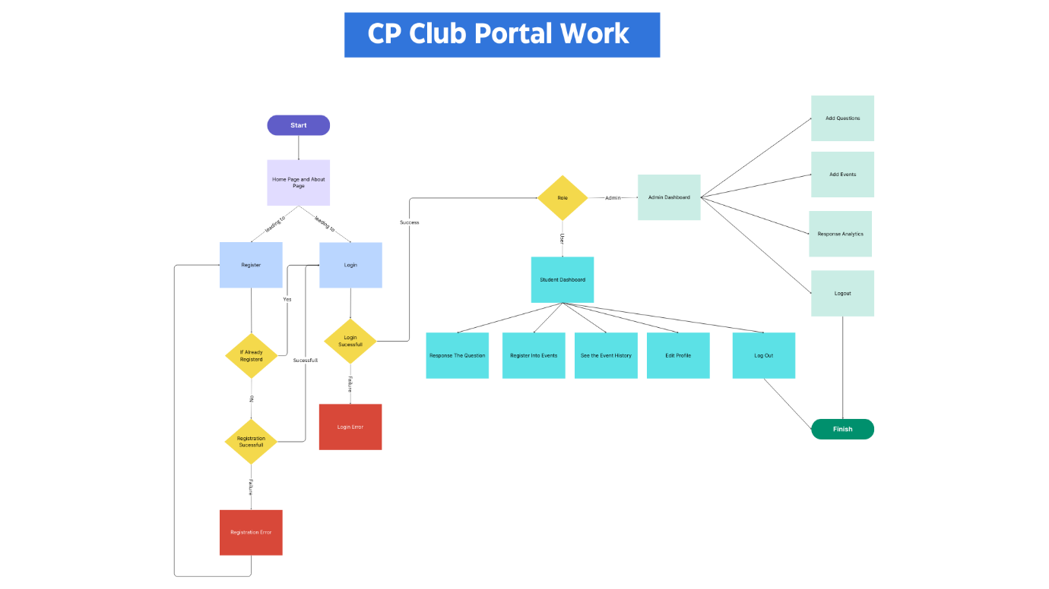

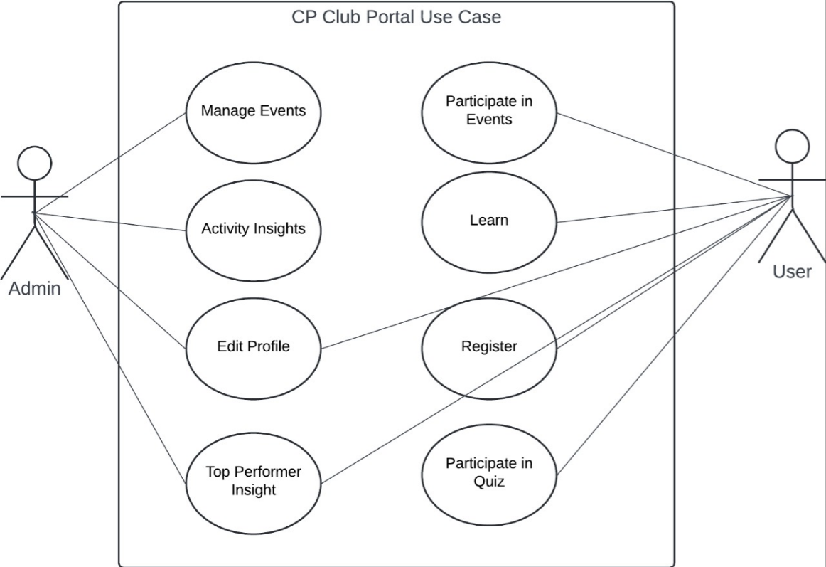

**Screenshots**

1. Home Page

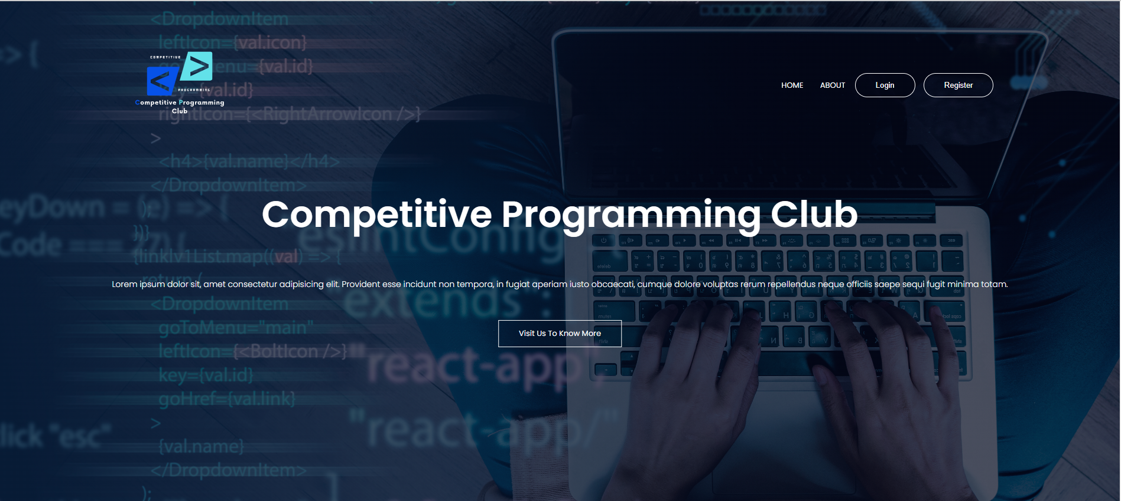

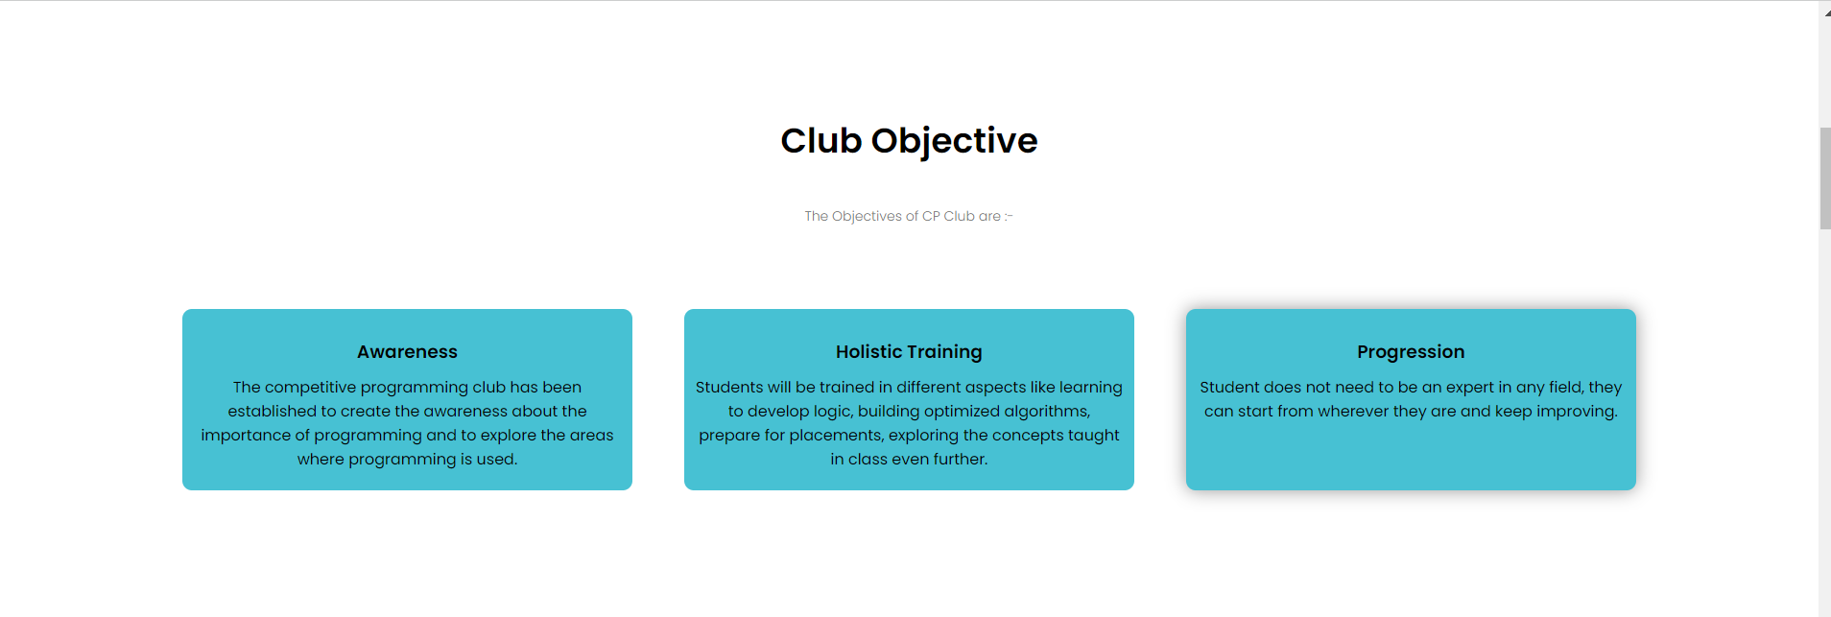

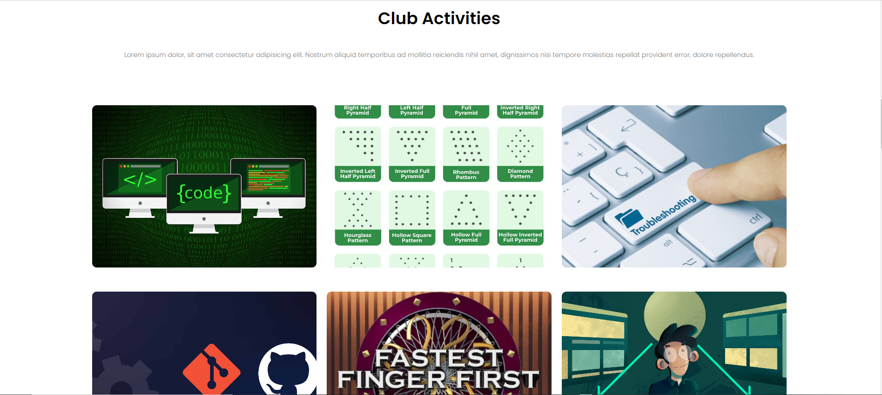

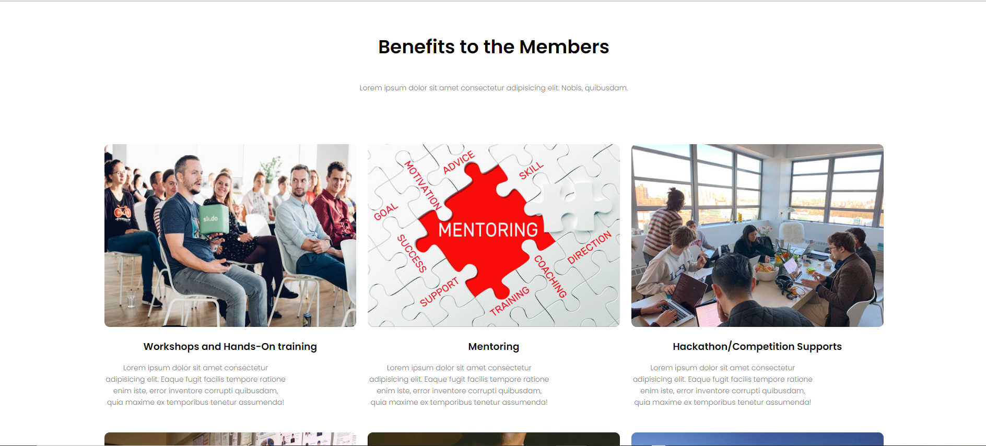

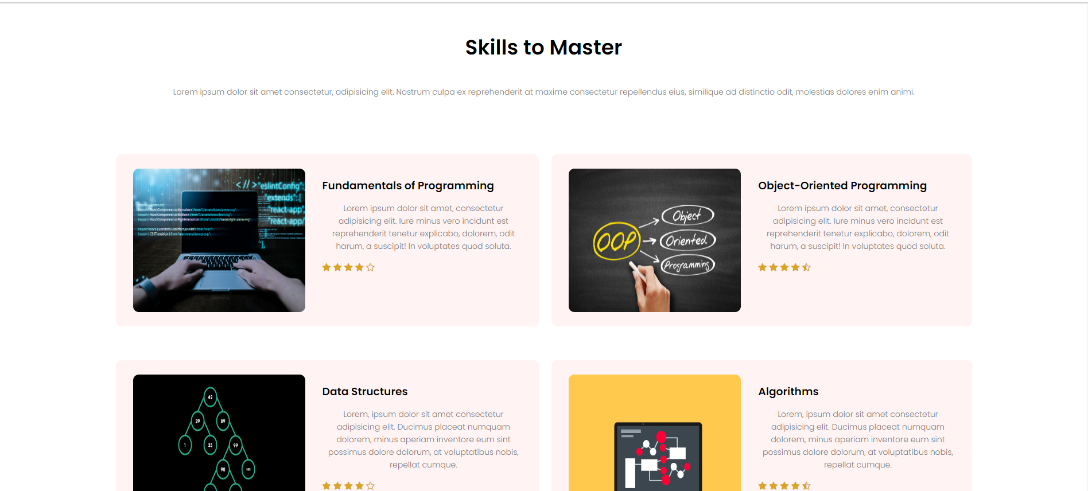

1. About Page

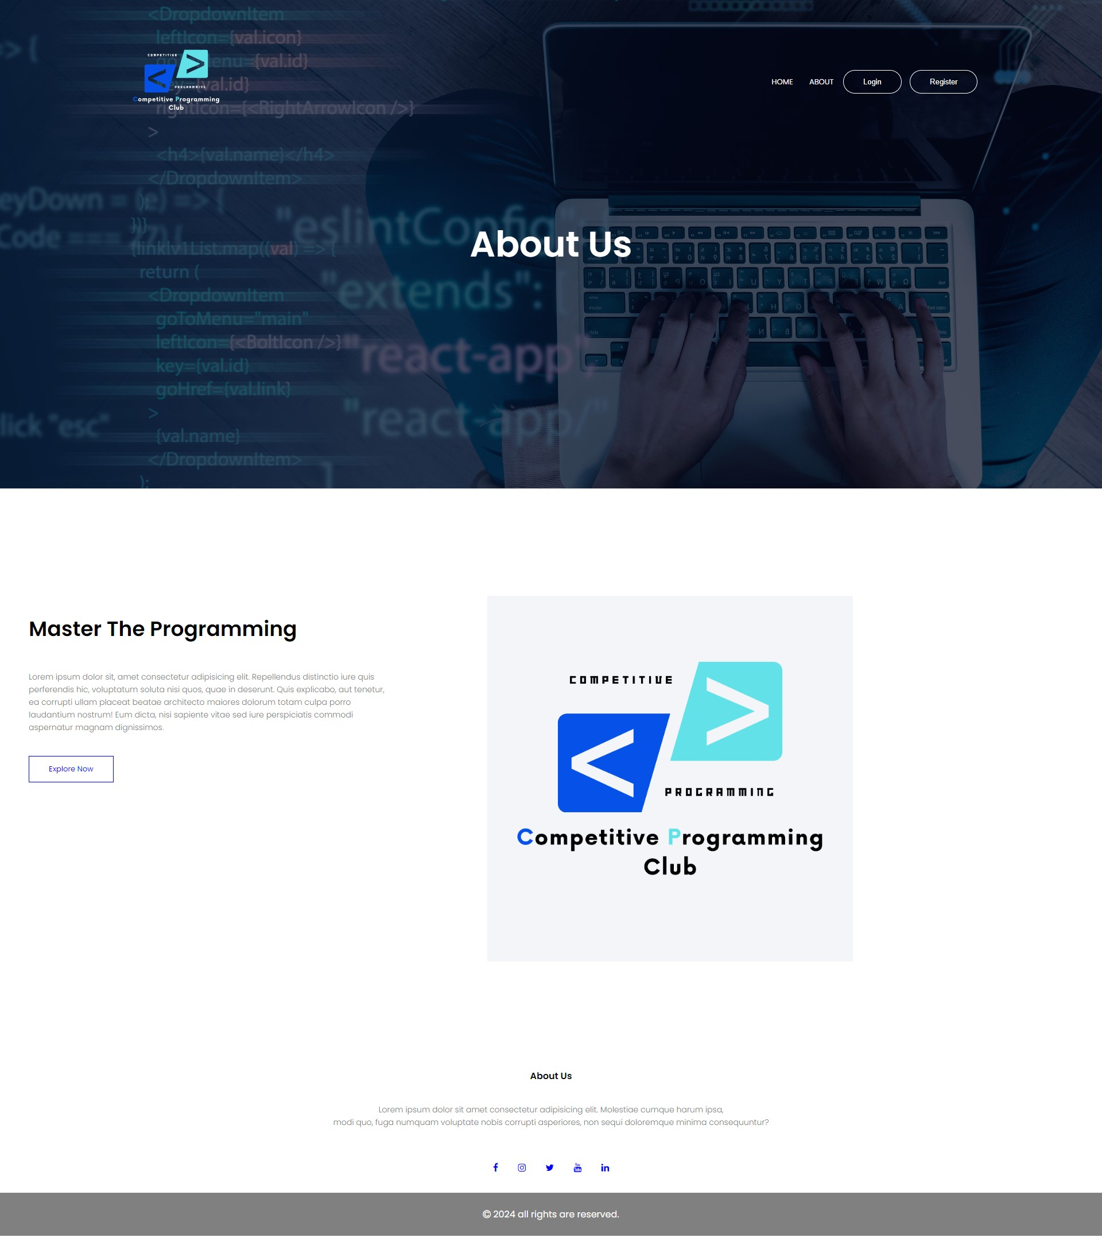

1. Registration Page

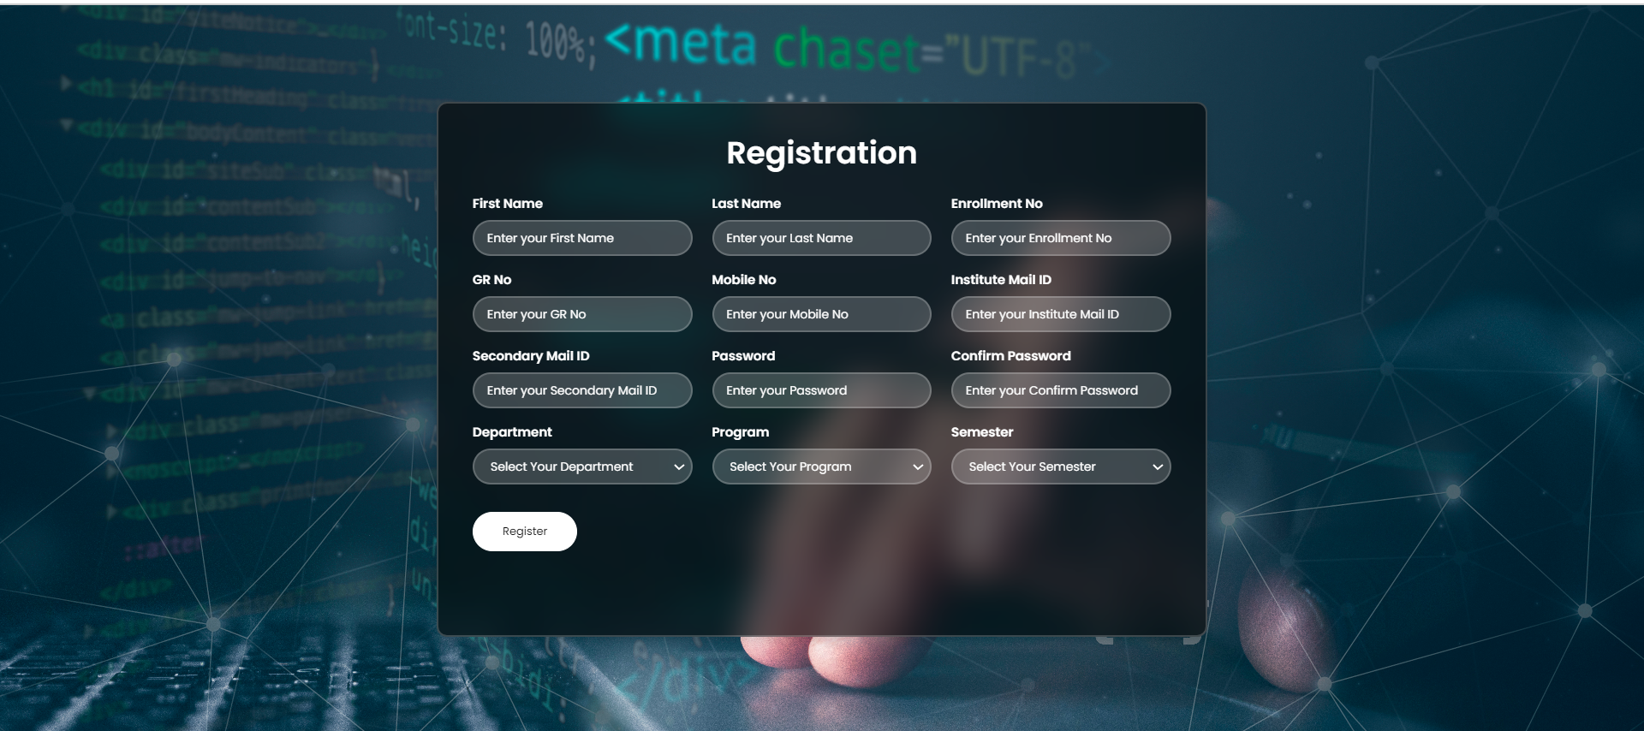

1. Log In Page

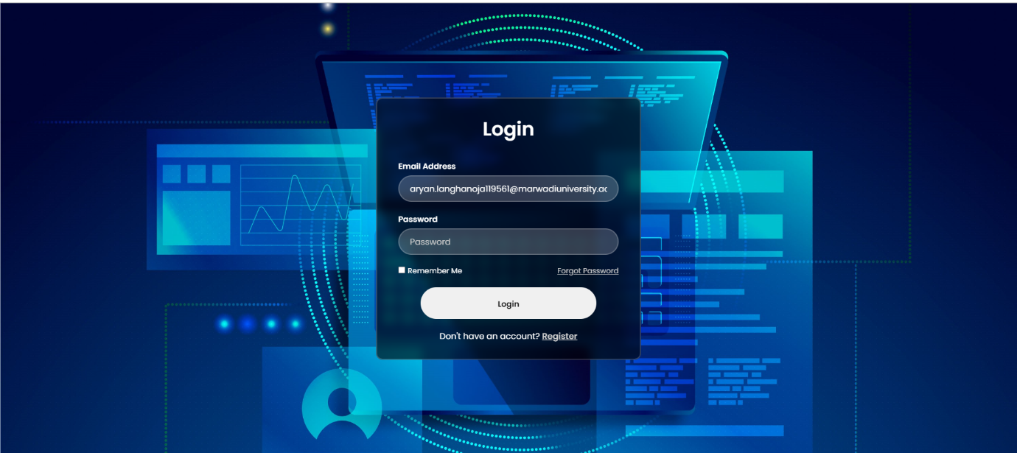

1. Admin Dashboard

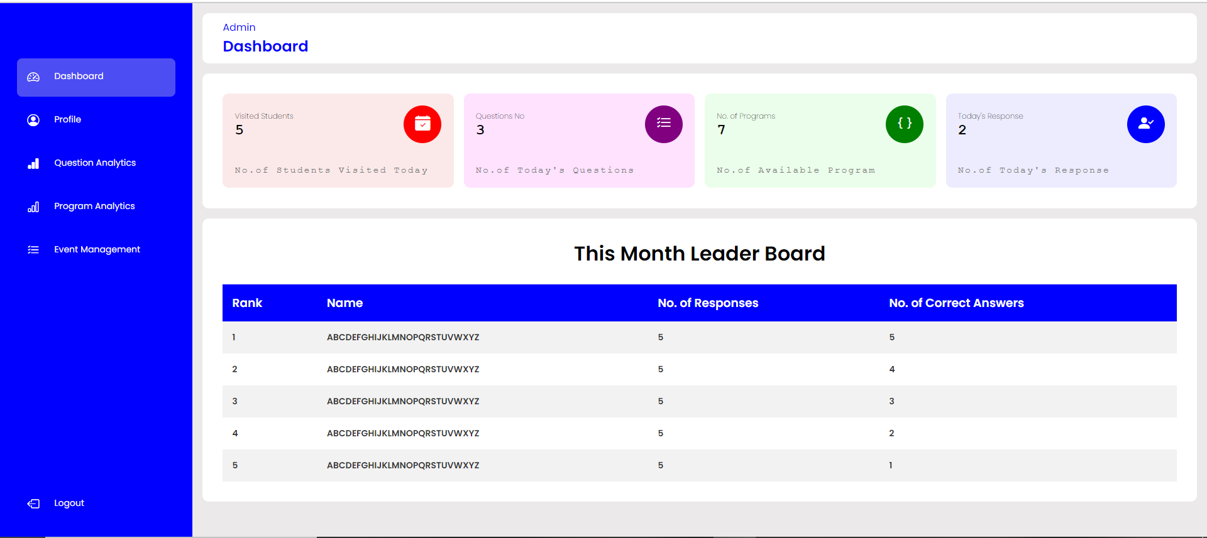

1. Event Creation



1. Profile Page

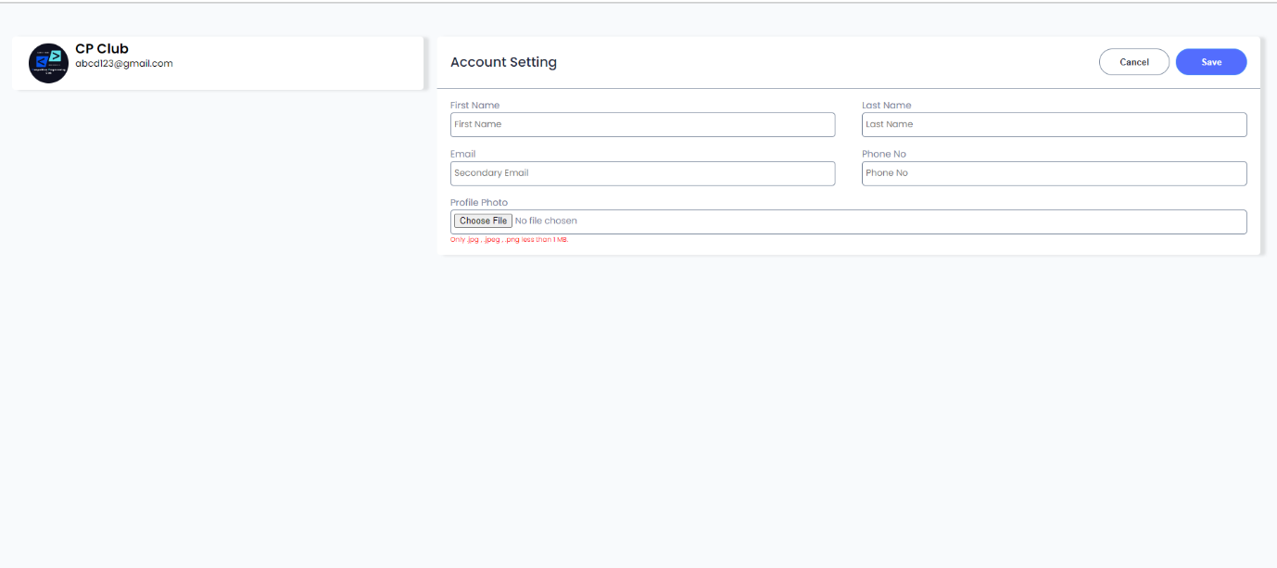

1. 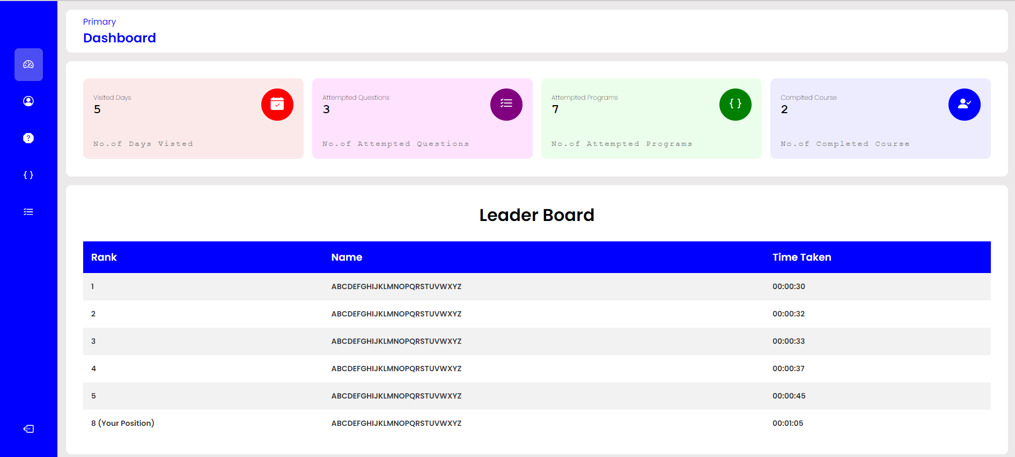User Dashboard
2. Event History

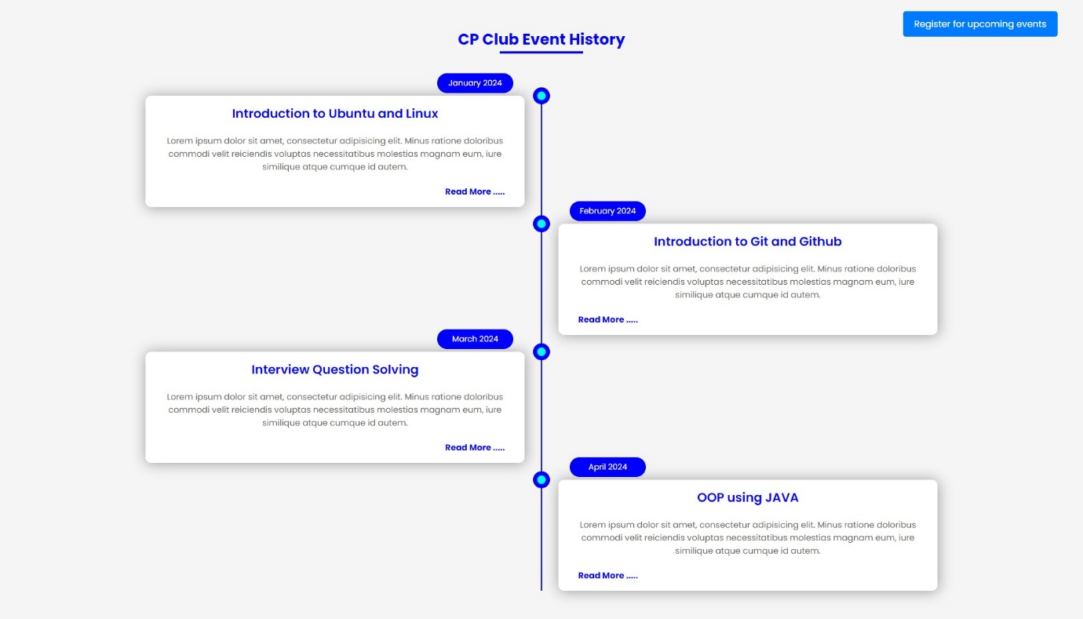

1. Event Registration

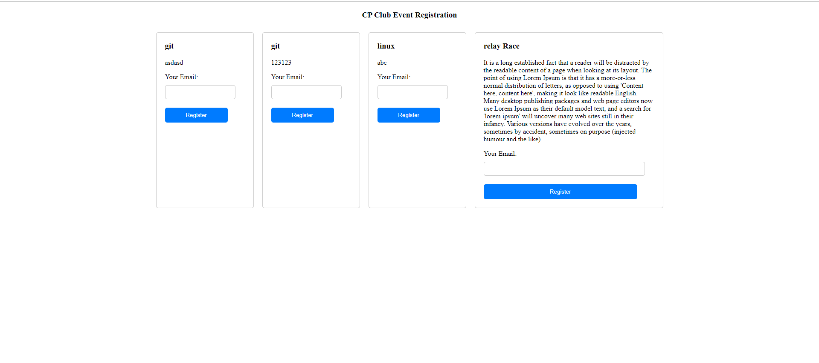

1. 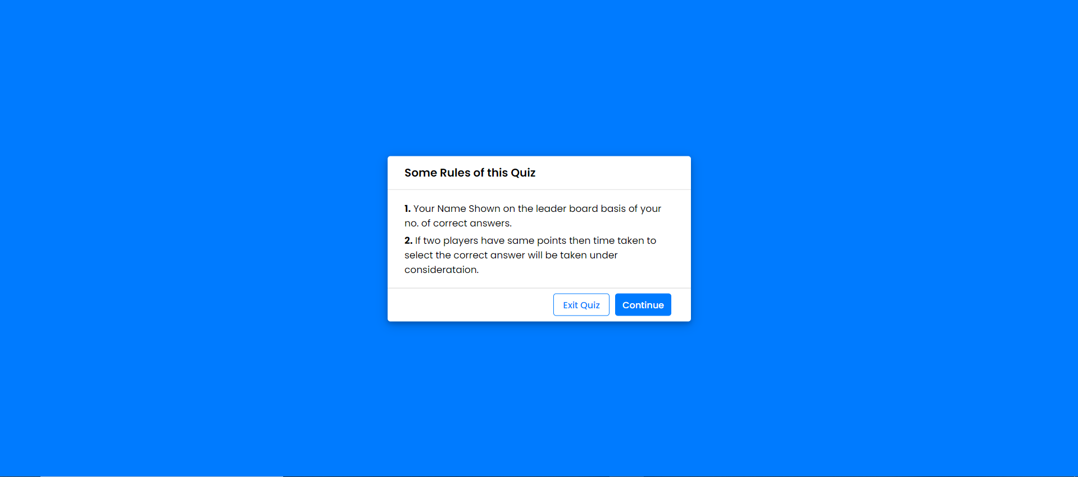Quiz Intro
2. 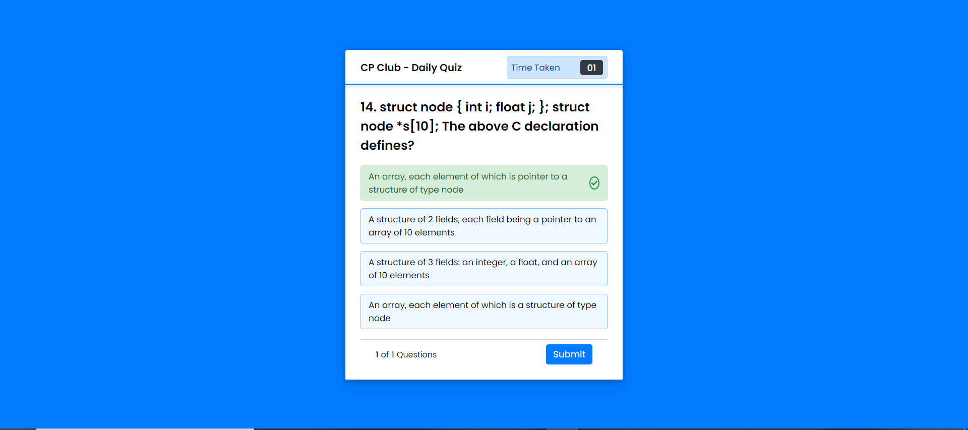Quiz

**Future Enhancement**

1. Integrate Compiler for Practice Programming:
2. Support for Large-Scale Deployment
3. Dynamic Certificate Generation
4. Payment Gateway Integration
5. In-depth statistical Insights of club members